Министерство науки и высшего образования Российской Федерации

Федеральное государственное бюджетное образовательное

учреждение высшего образования

«Комсомольский-на-Амуре государственный университет»

Факультет компьютерных технологий

Кафедра «Проектирование, управление и разработка информационных систем»

Отчет по лабораторной работе

по дисциплине «Интернет-технологии»

«Верстка»

Студент группы 0ВСб-1 А. М. Черников

Преподаватель В.С. Кортун

2023

**Задание**

Создать страницы своего сайта согласно варианту и заранее спроектированной структуре.

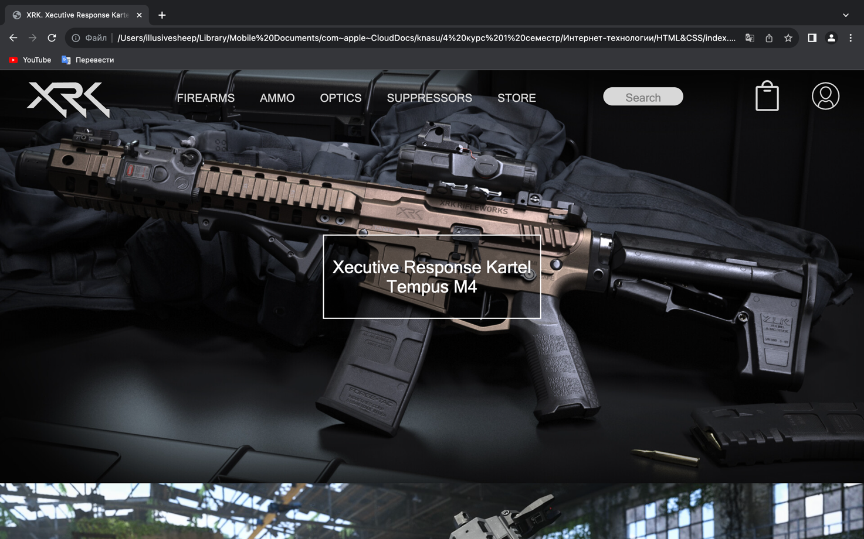  
Рисунок 1 – Главная страница

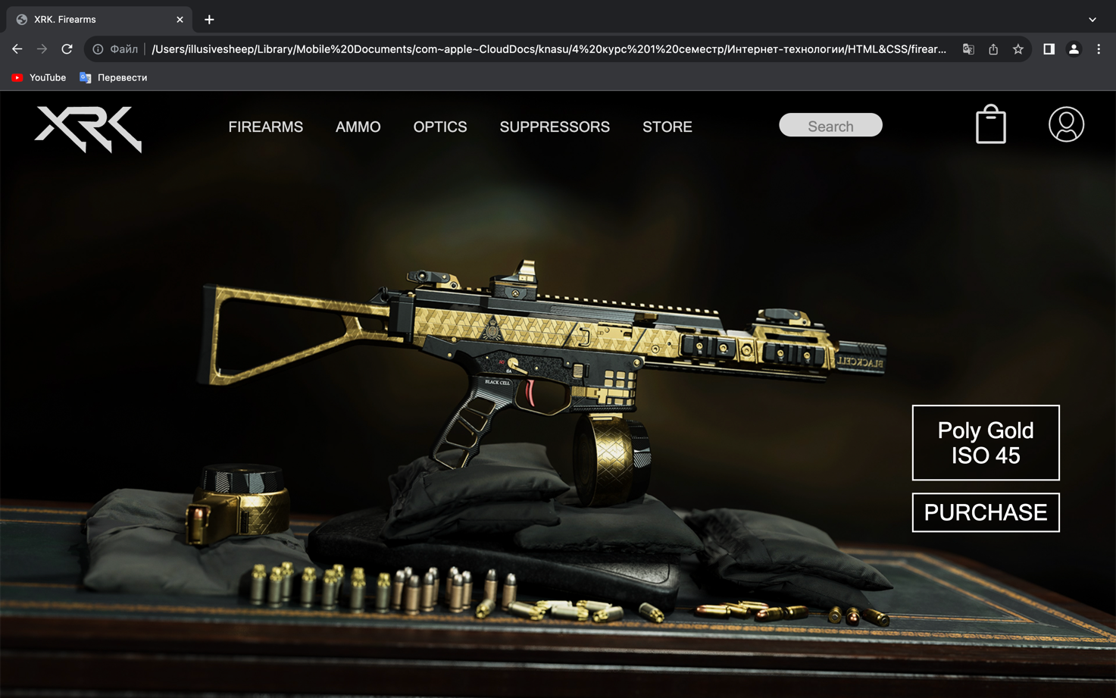  
Рисунок 2 – Страница покупки оружия

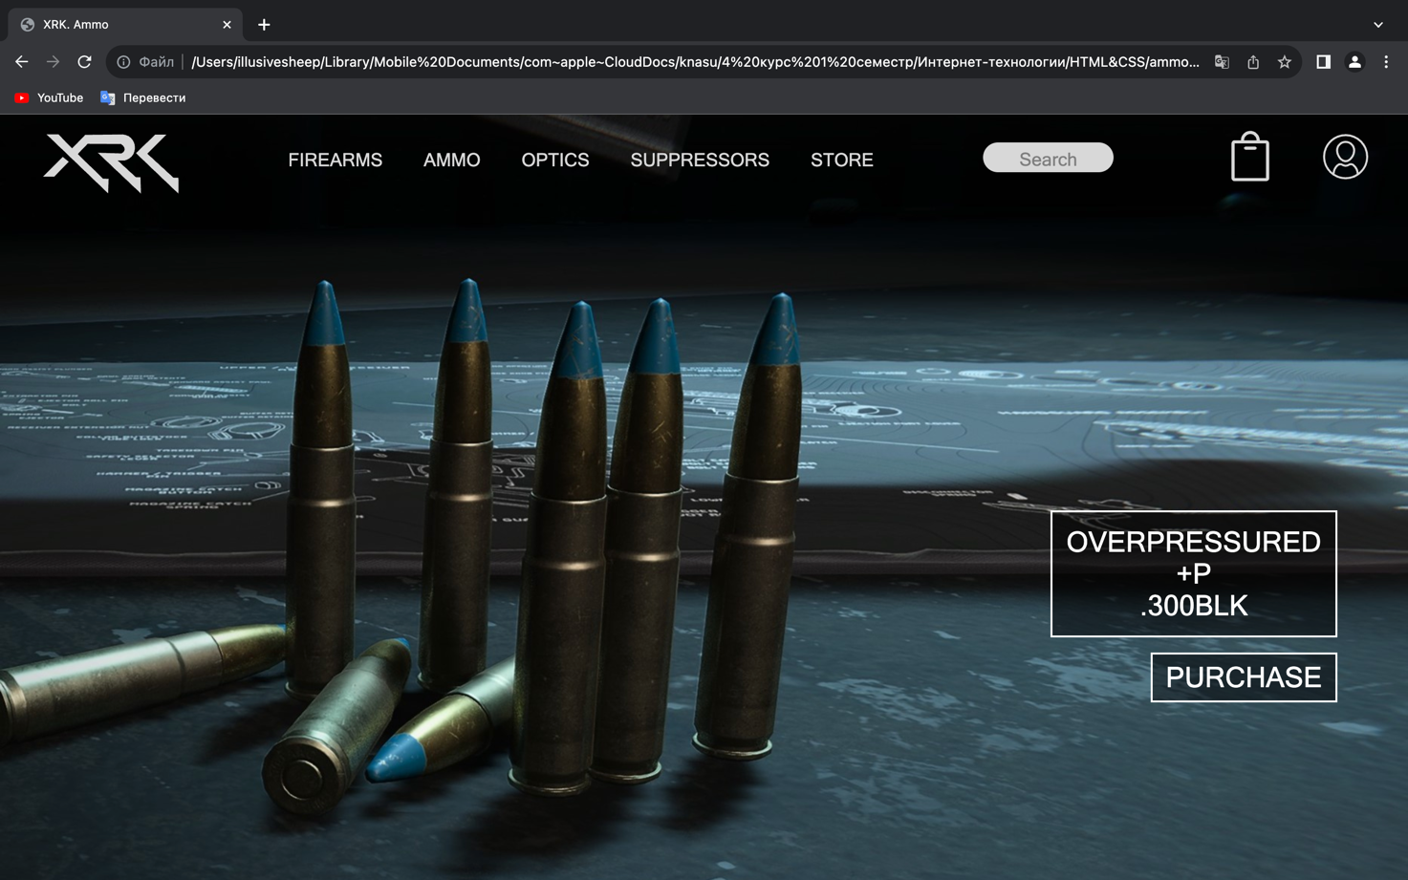  
Рисунок 3 – Страница покупки патронов

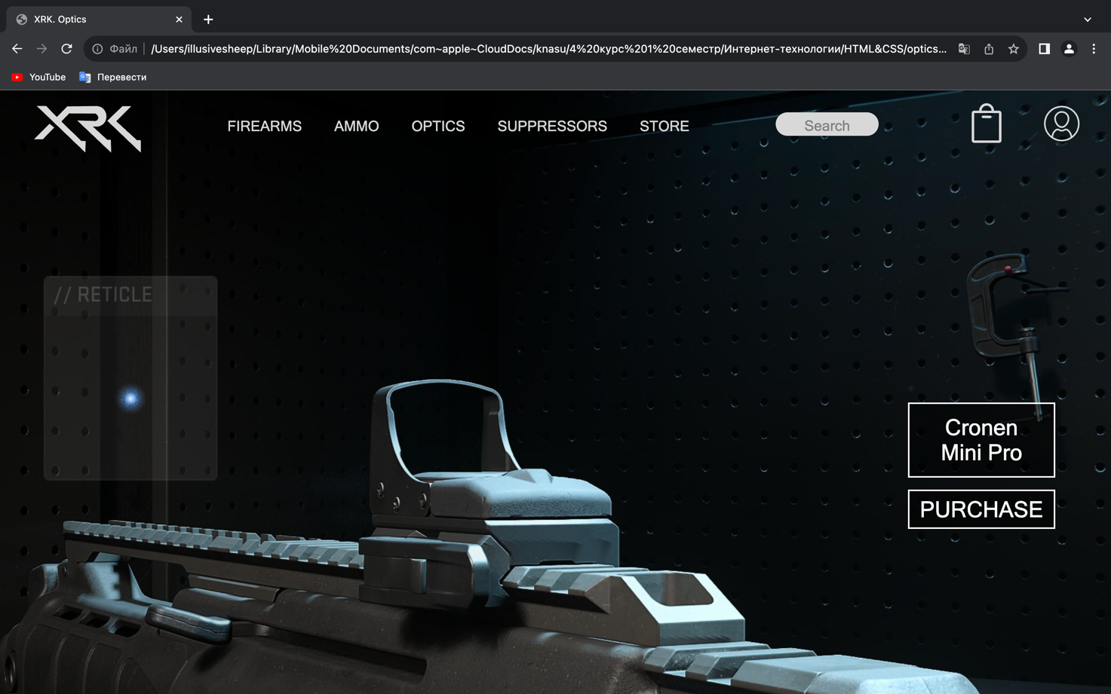

Рисунок 4 – Страница покупки прицелов

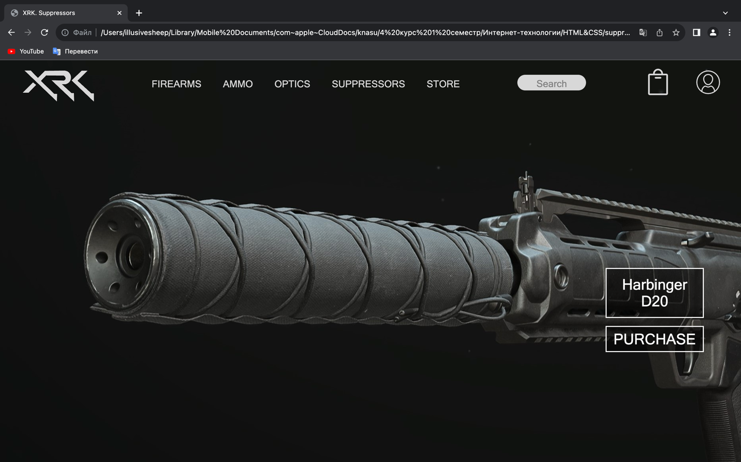  
Рисунок 5 – Страница покупки глушителей

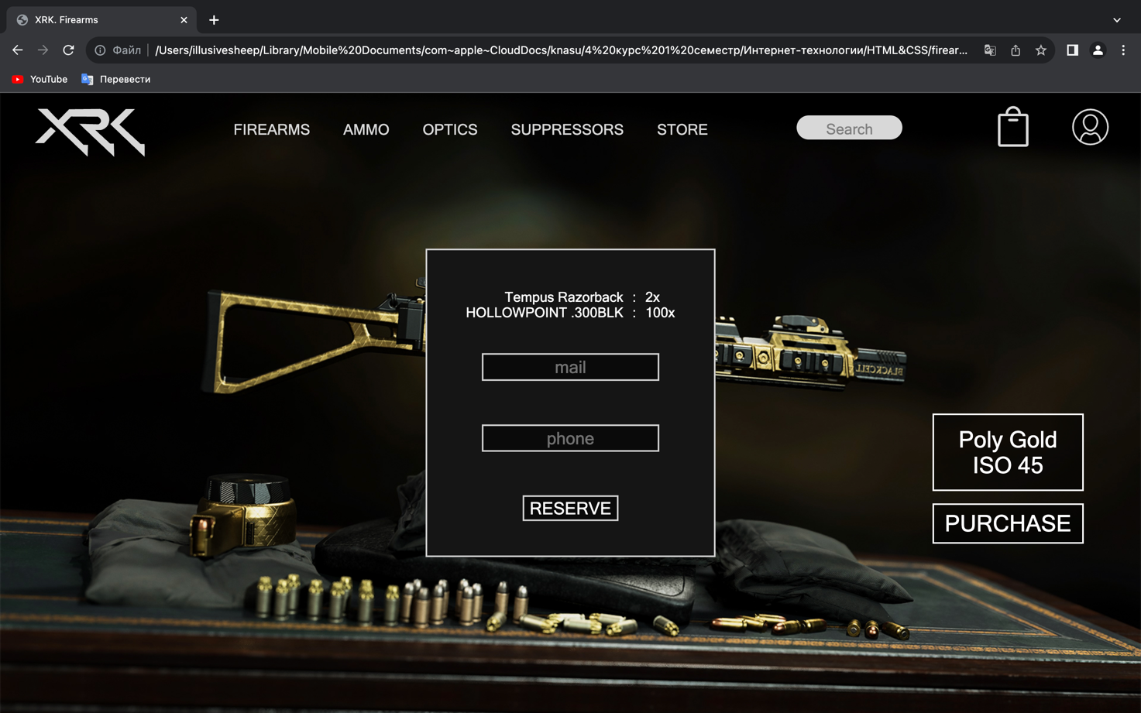

Рисунок 6 - Popup окно корзины

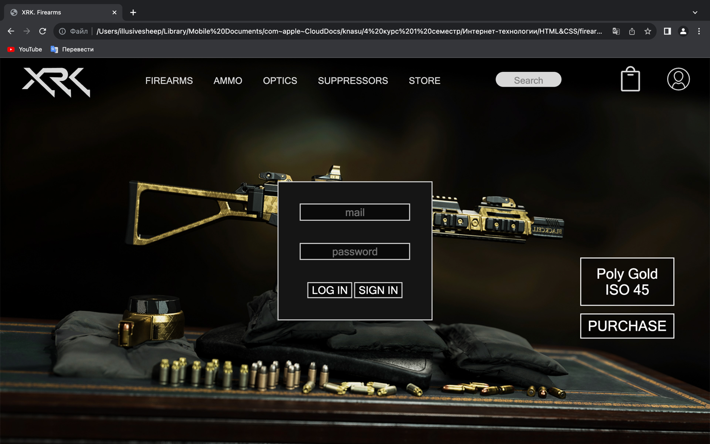

Рисунок 7 - Popup окно профиля

Листинг 1 – js/main.js

function showCart(){

let popup = document.getElementById("popup-cart")

let blocker = document.getElementById("blocker")

popup.style.visibility = 'visible'

popup.style.opacity = '1'

blocker.style.visibility = 'visible'

blocker.style.opacity = '1'

}

function hideCart(){

let popup = document.getElementById("popup-cart")

let blocker = document.getElementById("blocker")

popup.style.visibility = 'hidden'

popup.style.opacity = '0'

blocker.style.visibility = 'hidden'

blocker.style.opacity = '0'

}

let triggerShowCart = document.getElementById('cart')

triggerShowCart.addEventListener('click', showCart)

let triggerHideCart = document.getElementById('blocker')

triggerHideCart.addEventListener('click', hideCart)

function showProfile(){

let popup = document.getElementById("popup-profile")

let blocker = document.getElementById("blocker")

popup.style.visibility = 'visible'

popup.style.opacity = '1'

blocker.style.visibility = 'visible'

blocker.style.opacity = '1'

}

function hideProfile(){

let popup = document.getElementById("popup-profile")

let blocker = document.getElementById("blocker")

popup.style.visibility = 'hidden'

popup.style.opacity = '0'

blocker.style.visibility = 'hidden'

blocker.style.opacity = '0'

}

let triggerShowProfile = document.getElementById('profile')

triggerShowProfile.addEventListener('click', showProfile)

let triggerHideProfile = document.getElementById('blocker')

triggerHideProfile.addEventListener('click', hideProfile)

function createElementInside(src, text_list){

let root = document.getElementById('container')

let div_overlay = document.createElement('div')

div_overlay.classList.add('overlay-container')

let img = document.createElement('img')

img.classList.add('background-image')

img.src = src

img.alt = ''

let div_up = document.createElement('div')

div_up.classList.add('purchase-box-up')

let div_up_in = document.createElement('div')

let text = ''

for (let _text in text_list){

if(text !== '') text += '<br/>'

text += text_list[_text]

}

div_up_in.innerHTML = text

div_up.appendChild(div_up_in)

let div_purchase = document.createElement('div')

if(text_list.length === 1) div_purchase.classList.add('purchase-box1')

else if(text_list.length === 3) div_purchase.classList.add('purchase-box3')

else div_purchase.classList.add('purchase-box')

let div_purchase_in = document.createElement('div')

div_purchase_in.innerHTML = 'PURCHASE'

div_purchase.appendChild(div_purchase_in)

div_overlay.appendChild(img)

div_overlay.appendChild(div_up)

div_overlay.appendChild(div_purchase)

root.appendChild(div_overlay)

}

function createElementOverlay(src, text_list, rootID){

let root = document.getElementById(rootID)

let img = document.createElement('img')

img.classList.add('background-image')

img.src = src

img.alt = ''

let div_up = document.createElement('div')

div_up.classList.add('purchase-box-up')

let div_up_in = document.createElement('div')

let text = ''

for (let _text in text_list){

if(text !== '') text += '<br/>'

text += text_list[_text]

}

div_up_in.innerHTML = text

div_up.appendChild(div_up_in)

let div_purchase = document.createElement('div')

if(text_list.length === 1) div_purchase.classList.add('purchase-box1')

else if(text_list.length === 3) div_purchase.classList.add('purchase-box3')

else div_purchase.classList.add('purchase-box')

let div_purchase_in = document.createElement('div')

div_purchase_in.innerHTML = 'PURCHASE'

div_purchase.appendChild(div_purchase_in)

root.appendChild(img)

root.appendChild(div_up)

root.appendChild(div_purchase)

}

let path = window.location.pathname;

let page = path.split("/").pop();

let page_list = ['index.html', 'firearms.html', 'ammo.html', 'optics.html', 'suppressors.html']

let firearms_list = ['img/Firearms/ISO%2045%20Poly%20Gold.jpg', "img/Firearms/TAQ%20M%20Shadow.jpg", "img/Firearms/ISO%209.png", "img/Firearms/Tempus%20Razorback.jpg", "img/Firearms/ISO%2045%20Shadow.jpg"]

let ammo_list = ["img/Ammo/Overpressured_+P.jpg", "img/Ammo/Frangible.jpg", "img/Ammo/Hollowpoint.jpg", "img/Ammo/Armor_piercing.jpg", "img/Ammo/Armor_piercing1.jpg", "img/Ammo/Frangible1.jpg", "img/Ammo/High_Velocity.jpg", "img/Ammo/Hollowpoint1.jpg", "img/Ammo/Overpressured_+P1.jpg"]

let optics_list = ['img/Optics/Cronen_Mini_Pro.jpg', 'img/Optics/Hybrid_Firepoint.jpg', 'img/Optics/SZ_Holotherm.jpg', 'img/Optics/SZ_Lonewolf.jpg', 'img/Optics/XRK_On-Point.jpg']

let suppressors_list = ['img/Suppressors/Harbinger_D20.jpg', 'img/Suppressors/FSS_Covert_V.jpg', 'img/Suppressors/Expedite_EXF_Huntress-90.jpg', 'img/Suppressors/Xten_RR-40.jpg', 'img/Suppressors/Silentfire_XG6.jpg', 'img/Suppressors/FSS_Kavert_4.jpg', 'img/Suppressors/Echoline_GS-X.jpg', 'img/Suppressors/Broadhead_3DP.jpg']

let firearms_list_text = [['Poly Gold', 'ISO 45'], ['Shadow', 'TAQ M'], ['ISO 9'], ['Tempus', 'Razorback'], ['Shadow', 'ISO 45']]

let ammo_list_text = [['OVERPRESSURED', '+P', '.300BLK'], ['FRINGICLE', '.300BLK'], ['HOLLOWPOINT', '.300BLK'], ['ARMOR', 'PIERCING', '.300BLK'], ['ARMOR', 'PIERCING', '9mm'], ['FRINGICLE', '9 mm'], ['HIGH', 'VELOCITY', '9 mm'], ['HOLLOWPOINT', '9 mm'], ['OVERPRESSURED', '+P', '9 mm']]

let optics_list_text = [['Cronen', 'Mini Pro'], ['XTEN', 'Hybrid', 'Firepoint'], ['SZ', 'Holotherm'],['SZ', 'Lonewolf'], ['XRK', 'On-Point']]

let suppressors_list_text = [['Harbinger', 'D20'], ['FSS', 'Covert V'], ['Expedite', 'EXF', 'Huntress-90'], ['XTEN', 'RR-40'], ['Silentfire', 'XG6'], ['FSS', 'Covert 4'], ['Echoline', 'GS-X'], ['Broadhead', '3DP']]

let current_list, current_list_text

let isIndex = false

switch (page) {

case 'firearms.html': current_list = firearms_list; current_list_text = firearms_list_text; break

case 'ammo.html': current_list = ammo_list; current_list_text = ammo_list_text; break

case 'optics.html': current_list = optics_list; current_list_text = optics_list_text; break

case 'suppressors.html': current_list = suppressors_list; current_list_text = suppressors_list_text; break

default: isIndex = true

}

for(let current in current_list){

if(current === '0'){

createElementOverlay(current_list[current], current_list_text[current], 'overlay-container')

}else if(current === (current_list.length - 1).toString()){

createElementOverlay(current_list[current], current_list_text[current], 'bottom-container')

}else{

createElementInside(current_list[current], current_list_text[current])

}

}

Листинг 2 – css/main.css

:root{

--bg-color: #151515;

--accent-color: #D8D8D8;

--white-color: white;

--bg-fog: rgba(0,0,0,0.5)

}

html, body{

margin: 0;

padding: 0;

width: 100%;

height: 100%;

}

body{

background-color: var(--bg-color);

}

.overlay-container{

padding: 0;

margin: 0;

width: 100%;

position: relative;

}

.background-image{

width: 100%;

top: 0;

left: 0;

padding: 0;

margin: 0;

line-height: 0;

vertical-align: bottom;

object-fit:cover;

}

.last{

width: 100%;

height: 500px;

object-fit:cover;

}

.text-box{

z-index: 10;

block-size: fit-content;

top: 50%;

left: 50%;

transform: translate(-50%, -50%);

border: solid;

border-color: var(--white-color);

border-width: 2px;

position: absolute;

background: var(--bg-fog);

}

.text-box div{

text-align: center;

font-family: "Microsoft Sans Serif", sans-serif;

font-size: 2vw;

font-weight: normal;

color: var(--white-color);

margin: 2.5vw 1vw;

}

footer{

z-index: 10;

width: inherit;

height: 200px;

background: var(--bg-fog);

bottom: 0;

position: absolute;

vertical-align: center;

}

.logo{

z-index: 20;

block-size: fit-content;

width: 200px;

}

.footer-logo-align{

position: absolute;

text-align: center;

width: inherit;

top: 50%;

transform: translate(0, -50%);

}

header{

position: absolute;

top: 0;

left: 0;

width: 100%;

height: 200px;

}

header ul{

list-style-type: none;

margin: 0;

overflow: hidden;

padding: 1% 0 0 3%;

}

header ul li{

float: left;

}

.navigation{

display: block;

color: var(--accent-color);

text-align: center;

text-decoration: none;

font-family: "Microsoft Sans Serif", sans-serif;

font-size: 1.3vw;

font-weight: normal;

}

.navigation:hover:not(.active){

color: var(--white-color);

}

.navigation-li{

padding-top: 1.5%;

padding-left: 3%;

}

.header-logo{

block-size: fit-content;

}

.header-logo-align{

padding-top: 0.4%;

width: 10%;

padding-right: 5%;

}

.profile{

width: 4%;

padding-top: 0.4%;

padding-left: 3%;

}

.profile-logo{

block-size: fit-content;

fill: var(--accent-color);

}

.cart{

width: 4%;

padding-left: 8%;

}

.cart-logo{

block-size: fit-content;

fill: var(--accent-color);

}

.search-box-li{

padding-top: 1%;

padding-left: 8%;

}

.search-box-label{

}

.search-box{

height: 2vw;

width: 9vw;

border-radius: 50vw;

border: none;

background-color: var(--accent-color);

text-align: center;

}

.search-box::placeholder{

text-align: center;

text-decoration: none;

font-family: "Microsoft Sans Serif", sans-serif;

font-size: 1.3vw;

font-weight: normal;

color: rgba(40,40,40,0.51);

transform:translateY(0.3vw);

}

.popup{

position: fixed;

z-index: 100;

block-size: fit-content;

top: 50%;

left: 50%;

transform: translate(-50%, -50%);

border: solid;

border-color: var(--accent-color);

border-width: 2px;

background: var(--bg-color);

padding: 3%;

text-align: center;

opacity: 0;

visibility: hidden;

}

.popup label{

display: block;

padding-bottom: 20%;

}

.input-box{

height: 2vw;

width: 15vw;

border: solid;

border-color: var(--accent-color);

border-width: 2px;

background-color: var(--bg-fog);

text-align: center;

font-family: "Microsoft Sans Serif", sans-serif;

font-size: 1.5vw;

font-weight: normal;

color: var(--white-color);

}

.input-box::placeholder{

text-align: center;

font-family: "Microsoft Sans Serif", sans-serif;

font-size: 1.5vw;

font-weight: normal;

color: var(--accent-color);

opacity: 0.5;

}

.popup button{

border: solid;

border-color: var(--accent-color);

border-width: 2px;

background-color: var(--bg-fog);

text-align: center;

font-family: "Microsoft Sans Serif", sans-serif;

font-size: 1.5vw;

font-weight: normal;

color: var(--white-color);

}

.popup button:hover{

cursor: pointer;

}

.popup button div{

padding: 1px;

}

.popup .list{

display: flex;

}

.popup .name, .symbol, .quantity{

block-size: fit-content;

}

.popup ul{

list-style-type: none;

margin: 0;

overflow: hidden;

padding: 0.4vw 0.4vw 20%;

}

.popup .name li{

text-align: right;

font-family: "Microsoft Sans Serif", sans-serif;

font-size: 1.2vw;

font-weight: normal;

color: var(--white-color);

}

.popup .symbol li{

text-align: center;

font-family: "Microsoft Sans Serif", sans-serif;

font-size: 1.2vw;

font-weight: normal;

color: var(--white-color);

}

.popup .quantity li{

text-align: left;

font-family: "Microsoft Sans Serif", sans-serif;

font-size: 1.2vw;

font-weight: normal;

color: var(--white-color);

}

.blocker{

position: fixed;

margin: 0;

padding: 0;

width: 200%;

height: 200%;

z-index: 40;

opacity: 0;

visibility: hidden;

}

.purchase-box-up{

z-index: 10;

block-size: fit-content;

top: 50%;

right: 5%;

border: solid;

border-color: var(--white-color);

border-width: 2px;

position: absolute;

background: var(--bg-fog);

}

.purchase-box{

z-index: 10;

block-size: fit-content;

top: 64%;

right: 5%;

border: solid;

border-color: var(--white-color);

border-width: 2px;

position: absolute;

background: var(--bg-fog);

}

.purchase-box1{

z-index: 10;

block-size: fit-content;

top: 61%;

right: 5%;

border: solid;

border-color: var(--white-color);

border-width: 2px;

position: absolute;

background: var(--bg-fog);

}

.purchase-box3{

z-index: 10;

block-size: fit-content;

top: 68%;

right: 5%;

border: solid;

border-color: var(--white-color);

border-width: 2px;

position: absolute;

background: var(--bg-fog);

}

.purchase-box-up div{

text-align: center;

font-family: "Microsoft Sans Serif", sans-serif;

font-size: 2vw;

font-weight: normal;

color: var(--white-color);

margin: 1vw;

min-width: 11vw;

}

.purchase-box div{

text-align: center;

font-family: "Microsoft Sans Serif", sans-serif;

font-size: 2vw;

font-weight: normal;

color: var(--white-color);

margin: 0.5vw;

width: 12vw;

}

.purchase-box1 div{

text-align: center;

font-family: "Microsoft Sans Serif", sans-serif;

font-size: 2vw;

font-weight: normal;

color: var(--white-color);

margin: 0.5vw;

width: 12vw;

}

.purchase-box3 div{

text-align: center;

font-family: "Microsoft Sans Serif", sans-serif;

font-size: 2vw;

font-weight: normal;

color: var(--white-color);

margin: 0.5vw;

width: 12vw;

}

.purchase-box:hover{

cursor: pointer;

}

.profile:hover{

cursor: pointer;

}

.cart:hover{

cursor: pointer;

}

Листинг 3 – index.html

<!doctype html>

<html lang="en-ru">

<head>

<meta charset="utf-8">

<title>XRK. Xecutive Response Kartel</title>

<meta name="description" content="">

<meta name="viewport" content="width=device-width, initial-scale=1">

<meta property="og:title" content="">

<meta property="og:type" content="">

<meta property="og:url" content="">

<meta property="og:image" content="">

<link rel="manifest" href="site.webmanifest">

<link rel="apple-touch-icon" href="img/Logo/logo.svg">

<link rel="stylesheet" href="css/main.css">

<meta name="theme-color" content="#151515">

</head>

<body>

<script src="js/plugins.js"></script>

<div class="blocker" id="blocker"></div>

<div class="popup" id="popup-cart">

<div class="list">

<div class="name">

<ul>

<li>Tempus Razorback</li>

<li>HOLLOWPOINT .300BLK</li>

</ul>

</div>

<div class="symbol">

<ul>

<li>:</li>

<li>:</li>

</ul>

</div>

<div class="quantity">

<ul>

<li>2x</li>

<li>100x</li>

</ul>

</div>

</div>

<label>

<input class="input-box" name="mail" placeholder="mail">

</label>

<label>

<input class="input-box" name="phone" placeholder="phone">

</label>

<button name="reserve">

<div>

RESERVE

</div>

</button>

</div>

<div class="popup" id="popup-profile">

<label>

<input class="input-box" name="mail" placeholder="mail">

</label>

<label>

<input class="input-box" name="password" placeholder="password">

</label>

<button name="login">

<div>

LOG IN

</div>

</button>

<button name="signin">

<div>

SIGN IN

</div>

</button>

</div>

<div class="overlay-container">

<img class="background-image" src="img/Firearms/Tempus_M4_XRK.jpg" alt="">

<div class="text-box">

<div>Xecutive Response Kartel<br/>Tempus M4</div>

</div>

<header>

<ul>

<li class="header-logo-align">

<a href="index.html">

<svg class="header-logo" viewBox="150.646 181.341 231.725 102.181" xmlns="http://www.w3.org/2000/svg">

<path style="fill: rgb(216, 216, 216); stroke: rgb(0, 0, 0);" d="M 178.514 181.341 L 201.131 204.766 L 223.344 182.148 L 287.561 181.341 C 304.641 183.333 309.083 197.51 308.31 206.342 C 306.807 223.52 290.792 226.575 290.792 226.575 L 279.887 226.575 L 309.774 254.039 L 317.851 254.039 L 318.659 283.522 L 243.538 212.439 L 285.137 213.651 C 296.446 206.785 284.33 198.708 284.33 198.708 L 227.787 198.304 L 211.632 215.267 L 254.039 256.462 L 263.732 256.866 L 262.924 283.118 L 156.704 181.341 L 178.514 181.341 Z" transform="matrix(1, 0, 0, 1, 0, 3.552713678800501e-15)"/>

<path style="fill: rgb(216, 216, 216); stroke: rgb(0, 0, 0);" d="M 185.38 219.305 L 196.284 228.191 L 171.244 254.039 L 150.646 254.039 L 185.38 219.305 Z" transform="matrix(1, 0, 0, 1, 0, 3.552713678800501e-15)"/>

<path style="fill: rgb(216, 216, 216); stroke: rgb(0, 0, 0);" d="M 362.278 181.745 L 342.084 181.745 L 308.966 213.651 C 308.966 213.651 381.664 283.118 382.068 283.118 C 382.472 283.118 382.472 254.847 382.068 254.847 C 381.664 254.847 373.586 254.847 373.586 254.847 L 329.564 214.459 L 362.278 181.745 Z" transform="matrix(1, 0, 0, 1, 0, 3.552713678800501e-15)"/>

</svg>

</a>

</li>

<li class="navigation-li"><a class="navigation" href="firearms.html">FIREARMS</a></li>

<li class="navigation-li"><a class="navigation" href="ammo.html">AMMO</a></li>

<li class="navigation-li"><a class="navigation" href="optics.html">OPTICS</a></li>

<li class="navigation-li"><a class="navigation" href="suppressors.html">SUPPRESSORS</a></li>

<li class="navigation-li"><a class="navigation" href="firearms.html">STORE</a></li>

<li class="search-box-li">

<label class="search-box-label">

<input class="search-box" name="search" placeholder="Search">

</label>

</li>

<li class="cart" id="cart">

<svg class="cart-logo" xmlns="http://www.w3.org/2000/svg" viewBox="0 0 256 256" xml:space="preserve">

<path d="M201.8,54.2h-29.6C171.8,29.7,152.2,10,128,10S84.2,29.7,83.8,54.2H54.2c-8.1,0-14.7,6.6-14.7,14.7v162.3c0,8.1,6.6,14.8,14.7,14.8h147.5c8.1,0,14.8-6.6,14.8-14.8V69C216.5,60.9,209.9,54.2,201.8,54.2z M128,24.7c16,0,29.1,13.2,29.4,29.5H98.6C98.9,37.9,112,24.7,128,24.7z M201.8,231.3H54.2V69h147.5L201.8,231.3L201.8,231.3z"/><path d="M105.9,98.5h44.3c4,0,7.4-3.3,7.4-7.4c0-4.1-3.3-7.4-7.4-7.4h-44.3c-4.1,0-7.4,3.3-7.4,7.4C98.5,95.2,101.8,98.5,105.9,98.5z"/>

</svg>

</li>

<li class="profile" id="profile">

<svg class="profile-logo" xmlns="http://www.w3.org/2000/svg"

viewBox="0 0 402.161 402.161" xml:space="preserve">

<path d="M201.08,49.778c-38.794,0-70.355,31.561-70.355,70.355c0,18.828,7.425,40.193,19.862,57.151

c14.067,19.181,32,29.745,50.493,29.745c18.494,0,36.426-10.563,50.494-29.745c12.437-16.958,19.862-38.323,19.862-57.151

C271.436,81.339,239.874,49.778,201.08,49.778z M201.08,192.029c-13.396,0-27.391-8.607-38.397-23.616

c-10.46-14.262-16.958-32.762-16.958-48.28c0-30.523,24.832-55.355,55.355-55.355s55.355,24.832,55.355,55.355

C256.436,151.824,230.372,192.029,201.08,192.029z"/>

<path d="M201.08,0C109.387,0,34.788,74.598,34.788,166.292c0,91.693,74.598,166.292,166.292,166.292

s166.292-74.598,166.292-166.292C367.372,74.598,292.773,0,201.08,0z M201.08,317.584c-30.099-0.001-58.171-8.839-81.763-24.052

c0.82-22.969,11.218-44.503,28.824-59.454c6.996-5.941,17.212-6.59,25.422-1.615c8.868,5.374,18.127,8.099,27.52,8.099

c9.391,0,18.647-2.724,27.511-8.095c8.201-4.97,18.39-4.345,25.353,1.555c17.619,14.93,28.076,36.526,28.895,59.512

C259.25,308.746,231.178,317.584,201.08,317.584z M296.981,283.218c-3.239-23.483-15.011-45.111-33.337-60.64

c-11.89-10.074-29.1-11.256-42.824-2.939c-12.974,7.861-26.506,7.86-39.483-0.004c-13.74-8.327-30.981-7.116-42.906,3.01

c-18.31,15.549-30.035,37.115-33.265,60.563c-33.789-27.77-55.378-69.868-55.378-116.915C49.788,82.869,117.658,15,201.08,15

c83.423,0,151.292,67.869,151.292,151.292C352.372,213.345,330.778,255.448,296.981,283.218z"/>

</svg>

</li>

</ul>

</header>

</div>

<div class="index-after">

<img class="background-image" src="img/Firearms/ISO%209%20Prew.png" alt="">

</div>

<div class="overlay-container">

<img class="background-image" src="img/Firearms/Ghost.webp" alt="">

<footer>

<div class="footer-logo-align">

<svg class="logo" viewBox="150.646 181.341 231.725 102.181" xmlns="http://www.w3.org/2000/svg">

<path style="fill: rgb(216, 216, 216); stroke: rgb(0, 0, 0);" d="M 178.514 181.341 L 201.131 204.766 L 223.344 182.148 L 287.561 181.341 C 304.641 183.333 309.083 197.51 308.31 206.342 C 306.807 223.52 290.792 226.575 290.792 226.575 L 279.887 226.575 L 309.774 254.039 L 317.851 254.039 L 318.659 283.522 L 243.538 212.439 L 285.137 213.651 C 296.446 206.785 284.33 198.708 284.33 198.708 L 227.787 198.304 L 211.632 215.267 L 254.039 256.462 L 263.732 256.866 L 262.924 283.118 L 156.704 181.341 L 178.514 181.341 Z" transform="matrix(1, 0, 0, 1, 0, 3.552713678800501e-15)"/>

<path style="fill: rgb(216, 216, 216); stroke: rgb(0, 0, 0);" d="M 185.38 219.305 L 196.284 228.191 L 171.244 254.039 L 150.646 254.039 L 185.38 219.305 Z" transform="matrix(1, 0, 0, 1, 0, 3.552713678800501e-15)"/>

<path style="fill: rgb(216, 216, 216); stroke: rgb(0, 0, 0);" d="M 362.278 181.745 L 342.084 181.745 L 308.966 213.651 C 308.966 213.651 381.664 283.118 382.068 283.118 C 382.472 283.118 382.472 254.847 382.068 254.847 C 381.664 254.847 373.586 254.847 373.586 254.847 L 329.564 214.459 L 362.278 181.745 Z" transform="matrix(1, 0, 0, 1, 0, 3.552713678800501e-15)"/>

</svg>

</div>

</footer>

</div>

<script src="js/main.js"></script>

</body>

</html>

Листинг 4 – firearms.html

<!doctype html>

<html lang="en-ru">

<head>

<meta charset="utf-8">

<title>XRK. Firearms</title>

<meta name="description" content="">

<meta name="viewport" content="width=device-width, initial-scale=1">

<meta property="og:title" content="">

<meta property="og:type" content="">

<meta property="og:url" content="">

<meta property="og:image" content="">

<link rel="manifest" href="site.webmanifest">

<link rel="apple-touch-icon" href="img/Logo/logo.svg">

<link rel="stylesheet" href="css/main.css">

<meta name="theme-color" content="#151515">

</head>

<body>

<script src="js/plugins.js"></script>

<div class="blocker" id="blocker"></div>

<div class="popup" id="popup-cart">

<div class="list">

<div class="name">

<ul>

<li>Tempus Razorback</li>

<li>HOLLOWPOINT .300BLK</li>

</ul>

</div>

<div class="symbol">

<ul>

<li>:</li>

<li>:</li>

</ul>

</div>

<div class="quantity">

<ul>

<li>2x</li>

<li>100x</li>

</ul>

</div>

</div>

<label>

<input class="input-box" name="mail" placeholder="mail">

</label>

<label>

<input class="input-box" name="phone" placeholder="phone">

</label>

<button name="reserve">

<div>

RESERVE

</div>

</button>

</div>

<div class="popup" id="popup-profile">

<label>

<input class="input-box" name="mail" placeholder="mail">

</label>

<label>

<input class="input-box" name="password" placeholder="password">

</label>

<button name="login">

<div>

LOG IN

</div>

</button>

<button name="signin">

<div>

SIGN IN

</div>

</button>

</div>

<div class="overlay-container" id="overlay-container">

<header>

<ul>

<li class="header-logo-align">

<a href="index.html">

<svg class="header-logo" viewBox="150.646 181.341 231.725 102.181" xmlns="http://www.w3.org/2000/svg">

<path style="fill: rgb(216, 216, 216); stroke: rgb(0, 0, 0);" d="M 178.514 181.341 L 201.131 204.766 L 223.344 182.148 L 287.561 181.341 C 304.641 183.333 309.083 197.51 308.31 206.342 C 306.807 223.52 290.792 226.575 290.792 226.575 L 279.887 226.575 L 309.774 254.039 L 317.851 254.039 L 318.659 283.522 L 243.538 212.439 L 285.137 213.651 C 296.446 206.785 284.33 198.708 284.33 198.708 L 227.787 198.304 L 211.632 215.267 L 254.039 256.462 L 263.732 256.866 L 262.924 283.118 L 156.704 181.341 L 178.514 181.341 Z" transform="matrix(1, 0, 0, 1, 0, 3.552713678800501e-15)"/>

<path style="fill: rgb(216, 216, 216); stroke: rgb(0, 0, 0);" d="M 185.38 219.305 L 196.284 228.191 L 171.244 254.039 L 150.646 254.039 L 185.38 219.305 Z" transform="matrix(1, 0, 0, 1, 0, 3.552713678800501e-15)"/>

<path style="fill: rgb(216, 216, 216); stroke: rgb(0, 0, 0);" d="M 362.278 181.745 L 342.084 181.745 L 308.966 213.651 C 308.966 213.651 381.664 283.118 382.068 283.118 C 382.472 283.118 382.472 254.847 382.068 254.847 C 381.664 254.847 373.586 254.847 373.586 254.847 L 329.564 214.459 L 362.278 181.745 Z" transform="matrix(1, 0, 0, 1, 0, 3.552713678800501e-15)"/>

</svg>

</a>

</li>

<li class="navigation-li"><a class="navigation" href="firearms.html">FIREARMS</a></li>

<li class="navigation-li"><a class="navigation" href="ammo.html">AMMO</a></li>

<li class="navigation-li"><a class="navigation" href="optics.html">OPTICS</a></li>

<li class="navigation-li"><a class="navigation" href="suppressors.html">SUPPRESSORS</a></li>

<li class="navigation-li"><a class="navigation" href="firearms.html">STORE</a></li>

<li class="search-box-li">

<label class="search-box-label">

<input class="search-box" name="search" placeholder="Search">

</label>

</li>

<li class="cart" id="cart">

<svg class="cart-logo" xmlns="http://www.w3.org/2000/svg" viewBox="0 0 256 256" xml:space="preserve">

<path d="M201.8,54.2h-29.6C171.8,29.7,152.2,10,128,10S84.2,29.7,83.8,54.2H54.2c-8.1,0-14.7,6.6-14.7,14.7v162.3c0,8.1,6.6,14.8,14.7,14.8h147.5c8.1,0,14.8-6.6,14.8-14.8V69C216.5,60.9,209.9,54.2,201.8,54.2z M128,24.7c16,0,29.1,13.2,29.4,29.5H98.6C98.9,37.9,112,24.7,128,24.7z M201.8,231.3H54.2V69h147.5L201.8,231.3L201.8,231.3z"/><path d="M105.9,98.5h44.3c4,0,7.4-3.3,7.4-7.4c0-4.1-3.3-7.4-7.4-7.4h-44.3c-4.1,0-7.4,3.3-7.4,7.4C98.5,95.2,101.8,98.5,105.9,98.5z"/>

</svg>

</li>

<li class="profile" id="profile">

<svg class="profile-logo" xmlns="http://www.w3.org/2000/svg"

viewBox="0 0 402.161 402.161" xml:space="preserve">

<path d="M201.08,49.778c-38.794,0-70.355,31.561-70.355,70.355c0,18.828,7.425,40.193,19.862,57.151

c14.067,19.181,32,29.745,50.493,29.745c18.494,0,36.426-10.563,50.494-29.745c12.437-16.958,19.862-38.323,19.862-57.151

C271.436,81.339,239.874,49.778,201.08,49.778z M201.08,192.029c-13.396,0-27.391-8.607-38.397-23.616

c-10.46-14.262-16.958-32.762-16.958-48.28c0-30.523,24.832-55.355,55.355-55.355s55.355,24.832,55.355,55.355

C256.436,151.824,230.372,192.029,201.08,192.029z"/>

<path d="M201.08,0C109.387,0,34.788,74.598,34.788,166.292c0,91.693,74.598,166.292,166.292,166.292

s166.292-74.598,166.292-166.292C367.372,74.598,292.773,0,201.08,0z M201.08,317.584c-30.099-0.001-58.171-8.839-81.763-24.052

c0.82-22.969,11.218-44.503,28.824-59.454c6.996-5.941,17.212-6.59,25.422-1.615c8.868,5.374,18.127,8.099,27.52,8.099

c9.391,0,18.647-2.724,27.511-8.095c8.201-4.97,18.39-4.345,25.353,1.555c17.619,14.93,28.076,36.526,28.895,59.512

C259.25,308.746,231.178,317.584,201.08,317.584z M296.981,283.218c-3.239-23.483-15.011-45.111-33.337-60.64

c-11.89-10.074-29.1-11.256-42.824-2.939c-12.974,7.861-26.506,7.86-39.483-0.004c-13.74-8.327-30.981-7.116-42.906,3.01

c-18.31,15.549-30.035,37.115-33.265,60.563c-33.789-27.77-55.378-69.868-55.378-116.915C49.788,82.869,117.658,15,201.08,15

c83.423,0,151.292,67.869,151.292,151.292C352.372,213.345,330.778,255.448,296.981,283.218z"/>

</svg>

</li>

</ul>

</header>

</div>

<div class="container" id="container">

</div>

<div class="overlay-container" id="bottom-container">

<footer>

<div class="footer-logo-align">

<svg class="logo" viewBox="150.646 181.341 231.725 102.181" xmlns="http://www.w3.org/2000/svg">

<path style="fill: rgb(216, 216, 216); stroke: rgb(0, 0, 0);" d="M 178.514 181.341 L 201.131 204.766 L 223.344 182.148 L 287.561 181.341 C 304.641 183.333 309.083 197.51 308.31 206.342 C 306.807 223.52 290.792 226.575 290.792 226.575 L 279.887 226.575 L 309.774 254.039 L 317.851 254.039 L 318.659 283.522 L 243.538 212.439 L 285.137 213.651 C 296.446 206.785 284.33 198.708 284.33 198.708 L 227.787 198.304 L 211.632 215.267 L 254.039 256.462 L 263.732 256.866 L 262.924 283.118 L 156.704 181.341 L 178.514 181.341 Z" transform="matrix(1, 0, 0, 1, 0, 3.552713678800501e-15)"/>

<path style="fill: rgb(216, 216, 216); stroke: rgb(0, 0, 0);" d="M 185.38 219.305 L 196.284 228.191 L 171.244 254.039 L 150.646 254.039 L 185.38 219.305 Z" transform="matrix(1, 0, 0, 1, 0, 3.552713678800501e-15)"/>

<path style="fill: rgb(216, 216, 216); stroke: rgb(0, 0, 0);" d="M 362.278 181.745 L 342.084 181.745 L 308.966 213.651 C 308.966 213.651 381.664 283.118 382.068 283.118 C 382.472 283.118 382.472 254.847 382.068 254.847 C 381.664 254.847 373.586 254.847 373.586 254.847 L 329.564 214.459 L 362.278 181.745 Z" transform="matrix(1, 0, 0, 1, 0, 3.552713678800501e-15)"/>

</svg>

</div>

</footer>

</div>

<script src="js/main.js"></script>

</body>

</html>

Листинг 5 – ammo.html

<!doctype html>

<html lang="en-ru">

<head>

<meta charset="utf-8">

<title>XRK. Ammo</title>

<meta name="description" content="">

<meta name="viewport" content="width=device-width, initial-scale=1">

<meta property="og:title" content="">

<meta property="og:type" content="">

<meta property="og:url" content="">

<meta property="og:image" content="">

<link rel="manifest" href="site.webmanifest">

<link rel="apple-touch-icon" href="img/Logo/logo.svg">

<link rel="stylesheet" href="css/main.css">

<meta name="theme-color" content="#151515">

</head>

<body>

<script src="js/plugins.js"></script>

<div class="blocker" id="blocker"></div>

<div class="popup" id="popup-cart">

<div class="list">

<div class="name">

<ul>

<li>Tempus Razorback</li>

<li>HOLLOWPOINT .300BLK</li>

</ul>

</div>

<div class="symbol">

<ul>

<li>:</li>

<li>:</li>

</ul>

</div>

<div class="quantity">

<ul>

<li>2x</li>

<li>100x</li>

</ul>

</div>

</div>

<label>

<input class="input-box" name="mail" placeholder="mail">

</label>

<label>

<input class="input-box" name="phone" placeholder="phone">

</label>

<button name="reserve">

<div>

RESERVE

</div>

</button>

</div>

<div class="popup" id="popup-profile">

<label>

<input class="input-box" name="mail" placeholder="mail">

</label>

<label>

<input class="input-box" name="password" placeholder="password">

</label>

<button name="login">

<div>

LOG IN

</div>

</button>

<button name="signin">

<div>

SIGN IN

</div>

</button>

</div>

<div class="overlay-container" id="overlay-container">

<header>

<ul>

<li class="header-logo-align">

<a href="index.html">

<svg class="header-logo" viewBox="150.646 181.341 231.725 102.181" xmlns="http://www.w3.org/2000/svg">

<path style="fill: rgb(216, 216, 216); stroke: rgb(0, 0, 0);" d="M 178.514 181.341 L 201.131 204.766 L 223.344 182.148 L 287.561 181.341 C 304.641 183.333 309.083 197.51 308.31 206.342 C 306.807 223.52 290.792 226.575 290.792 226.575 L 279.887 226.575 L 309.774 254.039 L 317.851 254.039 L 318.659 283.522 L 243.538 212.439 L 285.137 213.651 C 296.446 206.785 284.33 198.708 284.33 198.708 L 227.787 198.304 L 211.632 215.267 L 254.039 256.462 L 263.732 256.866 L 262.924 283.118 L 156.704 181.341 L 178.514 181.341 Z" transform="matrix(1, 0, 0, 1, 0, 3.552713678800501e-15)"/>

<path style="fill: rgb(216, 216, 216); stroke: rgb(0, 0, 0);" d="M 185.38 219.305 L 196.284 228.191 L 171.244 254.039 L 150.646 254.039 L 185.38 219.305 Z" transform="matrix(1, 0, 0, 1, 0, 3.552713678800501e-15)"/>

<path style="fill: rgb(216, 216, 216); stroke: rgb(0, 0, 0);" d="M 362.278 181.745 L 342.084 181.745 L 308.966 213.651 C 308.966 213.651 381.664 283.118 382.068 283.118 C 382.472 283.118 382.472 254.847 382.068 254.847 C 381.664 254.847 373.586 254.847 373.586 254.847 L 329.564 214.459 L 362.278 181.745 Z" transform="matrix(1, 0, 0, 1, 0, 3.552713678800501e-15)"/>

</svg>

</a>

</li>

<li class="navigation-li"><a class="navigation" href="firearms.html">FIREARMS</a></li>

<li class="navigation-li"><a class="navigation" href="ammo.html">AMMO</a></li>

<li class="navigation-li"><a class="navigation" href="optics.html">OPTICS</a></li>

<li class="navigation-li"><a class="navigation" href="suppressors.html">SUPPRESSORS</a></li>

<li class="navigation-li"><a class="navigation" href="firearms.html">STORE</a></li>

<li class="search-box-li">

<label class="search-box-label">

<input class="search-box" name="search" placeholder="Search">

</label>

</li>

<li class="cart" id="cart">

<svg class="cart-logo" xmlns="http://www.w3.org/2000/svg" viewBox="0 0 256 256" xml:space="preserve">

<path d="M201.8,54.2h-29.6C171.8,29.7,152.2,10,128,10S84.2,29.7,83.8,54.2H54.2c-8.1,0-14.7,6.6-14.7,14.7v162.3c0,8.1,6.6,14.8,14.7,14.8h147.5c8.1,0,14.8-6.6,14.8-14.8V69C216.5,60.9,209.9,54.2,201.8,54.2z M128,24.7c16,0,29.1,13.2,29.4,29.5H98.6C98.9,37.9,112,24.7,128,24.7z M201.8,231.3H54.2V69h147.5L201.8,231.3L201.8,231.3z"/><path d="M105.9,98.5h44.3c4,0,7.4-3.3,7.4-7.4c0-4.1-3.3-7.4-7.4-7.4h-44.3c-4.1,0-7.4,3.3-7.4,7.4C98.5,95.2,101.8,98.5,105.9,98.5z"/>

</svg>

</li>

<li class="profile" id="profile">

<svg class="profile-logo" xmlns="http://www.w3.org/2000/svg"

viewBox="0 0 402.161 402.161" xml:space="preserve">

<path d="M201.08,49.778c-38.794,0-70.355,31.561-70.355,70.355c0,18.828,7.425,40.193,19.862,57.151

c14.067,19.181,32,29.745,50.493,29.745c18.494,0,36.426-10.563,50.494-29.745c12.437-16.958,19.862-38.323,19.862-57.151

C271.436,81.339,239.874,49.778,201.08,49.778z M201.08,192.029c-13.396,0-27.391-8.607-38.397-23.616

c-10.46-14.262-16.958-32.762-16.958-48.28c0-30.523,24.832-55.355,55.355-55.355s55.355,24.832,55.355,55.355

C256.436,151.824,230.372,192.029,201.08,192.029z"/>

<path d="M201.08,0C109.387,0,34.788,74.598,34.788,166.292c0,91.693,74.598,166.292,166.292,166.292

s166.292-74.598,166.292-166.292C367.372,74.598,292.773,0,201.08,0z M201.08,317.584c-30.099-0.001-58.171-8.839-81.763-24.052

c0.82-22.969,11.218-44.503,28.824-59.454c6.996-5.941,17.212-6.59,25.422-1.615c8.868,5.374,18.127,8.099,27.52,8.099

c9.391,0,18.647-2.724,27.511-8.095c8.201-4.97,18.39-4.345,25.353,1.555c17.619,14.93,28.076,36.526,28.895,59.512

C259.25,308.746,231.178,317.584,201.08,317.584z M296.981,283.218c-3.239-23.483-15.011-45.111-33.337-60.64

c-11.89-10.074-29.1-11.256-42.824-2.939c-12.974,7.861-26.506,7.86-39.483-0.004c-13.74-8.327-30.981-7.116-42.906,3.01

c-18.31,15.549-30.035,37.115-33.265,60.563c-33.789-27.77-55.378-69.868-55.378-116.915C49.788,82.869,117.658,15,201.08,15

c83.423,0,151.292,67.869,151.292,151.292C352.372,213.345,330.778,255.448,296.981,283.218z"/>

</svg>

</li>

</ul>

</header>

</div>

<div class="container" id="container">

</div>

<div class="overlay-container" id="bottom-container">

<footer>

<div class="footer-logo-align">

<svg class="logo" viewBox="150.646 181.341 231.725 102.181" xmlns="http://www.w3.org/2000/svg">

<path style="fill: rgb(216, 216, 216); stroke: rgb(0, 0, 0);" d="M 178.514 181.341 L 201.131 204.766 L 223.344 182.148 L 287.561 181.341 C 304.641 183.333 309.083 197.51 308.31 206.342 C 306.807 223.52 290.792 226.575 290.792 226.575 L 279.887 226.575 L 309.774 254.039 L 317.851 254.039 L 318.659 283.522 L 243.538 212.439 L 285.137 213.651 C 296.446 206.785 284.33 198.708 284.33 198.708 L 227.787 198.304 L 211.632 215.267 L 254.039 256.462 L 263.732 256.866 L 262.924 283.118 L 156.704 181.341 L 178.514 181.341 Z" transform="matrix(1, 0, 0, 1, 0, 3.552713678800501e-15)"/>

<path style="fill: rgb(216, 216, 216); stroke: rgb(0, 0, 0);" d="M 185.38 219.305 L 196.284 228.191 L 171.244 254.039 L 150.646 254.039 L 185.38 219.305 Z" transform="matrix(1, 0, 0, 1, 0, 3.552713678800501e-15)"/>

<path style="fill: rgb(216, 216, 216); stroke: rgb(0, 0, 0);" d="M 362.278 181.745 L 342.084 181.745 L 308.966 213.651 C 308.966 213.651 381.664 283.118 382.068 283.118 C 382.472 283.118 382.472 254.847 382.068 254.847 C 381.664 254.847 373.586 254.847 373.586 254.847 L 329.564 214.459 L 362.278 181.745 Z" transform="matrix(1, 0, 0, 1, 0, 3.552713678800501e-15)"/>

</svg>

</div>

</footer>

</div>

<script src="js/main.js"></script>

</body>

</html>

Листинг 6 – optics.html

<!doctype html>

<html lang="en-ru">

<head>

<meta charset="utf-8">

<title>XRK. Optics</title>

<meta name="description" content="">

<meta name="viewport" content="width=device-width, initial-scale=1">

<meta property="og:title" content="">

<meta property="og:type" content="">

<meta property="og:url" content="">

<meta property="og:image" content="">

<link rel="manifest" href="site.webmanifest">

<link rel="apple-touch-icon" href="img/Logo/logo.svg">

<link rel="stylesheet" href="css/main.css">

<meta name="theme-color" content="#151515">

</head>

<body>

<script src="js/plugins.js"></script>

<div class="blocker" id="blocker"></div>

<div class="popup" id="popup-cart">

<div class="list">

<div class="name">

<ul>

<li>Tempus Razorback</li>

<li>HOLLOWPOINT .300BLK</li>

</ul>

</div>

<div class="symbol">

<ul>

<li>:</li>

<li>:</li>

</ul>

</div>

<div class="quantity">

<ul>

<li>2x</li>

<li>100x</li>

</ul>

</div>

</div>

<label>

<input class="input-box" name="mail" placeholder="mail">

</label>

<label>

<input class="input-box" name="phone" placeholder="phone">

</label>

<button name="reserve">

<div>

RESERVE

</div>

</button>

</div>

<div class="popup" id="popup-profile">

<label>

<input class="input-box" name="mail" placeholder="mail">

</label>

<label>

<input class="input-box" name="password" placeholder="password">

</label>

<button name="login">

<div>

LOG IN

</div>

</button>

<button name="signin">

<div>

SIGN IN

</div>

</button>

</div>

<div class="overlay-container" id="overlay-container">

<header>

<ul>

<li class="header-logo-align">

<a href="index.html">

<svg class="header-logo" viewBox="150.646 181.341 231.725 102.181" xmlns="http://www.w3.org/2000/svg">

<path style="fill: rgb(216, 216, 216); stroke: rgb(0, 0, 0);" d="M 178.514 181.341 L 201.131 204.766 L 223.344 182.148 L 287.561 181.341 C 304.641 183.333 309.083 197.51 308.31 206.342 C 306.807 223.52 290.792 226.575 290.792 226.575 L 279.887 226.575 L 309.774 254.039 L 317.851 254.039 L 318.659 283.522 L 243.538 212.439 L 285.137 213.651 C 296.446 206.785 284.33 198.708 284.33 198.708 L 227.787 198.304 L 211.632 215.267 L 254.039 256.462 L 263.732 256.866 L 262.924 283.118 L 156.704 181.341 L 178.514 181.341 Z" transform="matrix(1, 0, 0, 1, 0, 3.552713678800501e-15)"/>

<path style="fill: rgb(216, 216, 216); stroke: rgb(0, 0, 0);" d="M 185.38 219.305 L 196.284 228.191 L 171.244 254.039 L 150.646 254.039 L 185.38 219.305 Z" transform="matrix(1, 0, 0, 1, 0, 3.552713678800501e-15)"/>

<path style="fill: rgb(216, 216, 216); stroke: rgb(0, 0, 0);" d="M 362.278 181.745 L 342.084 181.745 L 308.966 213.651 C 308.966 213.651 381.664 283.118 382.068 283.118 C 382.472 283.118 382.472 254.847 382.068 254.847 C 381.664 254.847 373.586 254.847 373.586 254.847 L 329.564 214.459 L 362.278 181.745 Z" transform="matrix(1, 0, 0, 1, 0, 3.552713678800501e-15)"/>

</svg>

</a>

</li>

<li class="navigation-li"><a class="navigation" href="firearms.html">FIREARMS</a></li>

<li class="navigation-li"><a class="navigation" href="ammo.html">AMMO</a></li>

<li class="navigation-li"><a class="navigation" href="optics.html">OPTICS</a></li>

<li class="navigation-li"><a class="navigation" href="suppressors.html">SUPPRESSORS</a></li>

<li class="navigation-li"><a class="navigation" href="firearms.html">STORE</a></li>

<li class="search-box-li">

<label class="search-box-label">

<input class="search-box" name="search" placeholder="Search">

</label>

</li>

<li class="cart" id="cart">

<svg class="cart-logo" xmlns="http://www.w3.org/2000/svg" viewBox="0 0 256 256" xml:space="preserve">

<path d="M201.8,54.2h-29.6C171.8,29.7,152.2,10,128,10S84.2,29.7,83.8,54.2H54.2c-8.1,0-14.7,6.6-14.7,14.7v162.3c0,8.1,6.6,14.8,14.7,14.8h147.5c8.1,0,14.8-6.6,14.8-14.8V69C216.5,60.9,209.9,54.2,201.8,54.2z M128,24.7c16,0,29.1,13.2,29.4,29.5H98.6C98.9,37.9,112,24.7,128,24.7z M201.8,231.3H54.2V69h147.5L201.8,231.3L201.8,231.3z"/><path d="M105.9,98.5h44.3c4,0,7.4-3.3,7.4-7.4c0-4.1-3.3-7.4-7.4-7.4h-44.3c-4.1,0-7.4,3.3-7.4,7.4C98.5,95.2,101.8,98.5,105.9,98.5z"/>

</svg>

</li>

<li class="profile" id="profile">

<svg class="profile-logo" xmlns="http://www.w3.org/2000/svg"

viewBox="0 0 402.161 402.161" xml:space="preserve">

<path d="M201.08,49.778c-38.794,0-70.355,31.561-70.355,70.355c0,18.828,7.425,40.193,19.862,57.151

c14.067,19.181,32,29.745,50.493,29.745c18.494,0,36.426-10.563,50.494-29.745c12.437-16.958,19.862-38.323,19.862-57.151

C271.436,81.339,239.874,49.778,201.08,49.778z M201.08,192.029c-13.396,0-27.391-8.607-38.397-23.616

c-10.46-14.262-16.958-32.762-16.958-48.28c0-30.523,24.832-55.355,55.355-55.355s55.355,24.832,55.355,55.355

C256.436,151.824,230.372,192.029,201.08,192.029z"/>

<path d="M201.08,0C109.387,0,34.788,74.598,34.788,166.292c0,91.693,74.598,166.292,166.292,166.292

s166.292-74.598,166.292-166.292C367.372,74.598,292.773,0,201.08,0z M201.08,317.584c-30.099-0.001-58.171-8.839-81.763-24.052

c0.82-22.969,11.218-44.503,28.824-59.454c6.996-5.941,17.212-6.59,25.422-1.615c8.868,5.374,18.127,8.099,27.52,8.099

c9.391,0,18.647-2.724,27.511-8.095c8.201-4.97,18.39-4.345,25.353,1.555c17.619,14.93,28.076,36.526,28.895,59.512

C259.25,308.746,231.178,317.584,201.08,317.584z M296.981,283.218c-3.239-23.483-15.011-45.111-33.337-60.64

c-11.89-10.074-29.1-11.256-42.824-2.939c-12.974,7.861-26.506,7.86-39.483-0.004c-13.74-8.327-30.981-7.116-42.906,3.01

c-18.31,15.549-30.035,37.115-33.265,60.563c-33.789-27.77-55.378-69.868-55.378-116.915C49.788,82.869,117.658,15,201.08,15

c83.423,0,151.292,67.869,151.292,151.292C352.372,213.345,330.778,255.448,296.981,283.218z"/>

</svg>

</li>

</ul>

</header>

</div>

<div class="container" id="container">

</div>

<div class="overlay-container" id="bottom-container">

<footer>

<div class="footer-logo-align">

<svg class="logo" viewBox="150.646 181.341 231.725 102.181" xmlns="http://www.w3.org/2000/svg">

<path style="fill: rgb(216, 216, 216); stroke: rgb(0, 0, 0);" d="M 178.514 181.341 L 201.131 204.766 L 223.344 182.148 L 287.561 181.341 C 304.641 183.333 309.083 197.51 308.31 206.342 C 306.807 223.52 290.792 226.575 290.792 226.575 L 279.887 226.575 L 309.774 254.039 L 317.851 254.039 L 318.659 283.522 L 243.538 212.439 L 285.137 213.651 C 296.446 206.785 284.33 198.708 284.33 198.708 L 227.787 198.304 L 211.632 215.267 L 254.039 256.462 L 263.732 256.866 L 262.924 283.118 L 156.704 181.341 L 178.514 181.341 Z" transform="matrix(1, 0, 0, 1, 0, 3.552713678800501e-15)"/>

<path style="fill: rgb(216, 216, 216); stroke: rgb(0, 0, 0);" d="M 185.38 219.305 L 196.284 228.191 L 171.244 254.039 L 150.646 254.039 L 185.38 219.305 Z" transform="matrix(1, 0, 0, 1, 0, 3.552713678800501e-15)"/>

<path style="fill: rgb(216, 216, 216); stroke: rgb(0, 0, 0);" d="M 362.278 181.745 L 342.084 181.745 L 308.966 213.651 C 308.966 213.651 381.664 283.118 382.068 283.118 C 382.472 283.118 382.472 254.847 382.068 254.847 C 381.664 254.847 373.586 254.847 373.586 254.847 L 329.564 214.459 L 362.278 181.745 Z" transform="matrix(1, 0, 0, 1, 0, 3.552713678800501e-15)"/>

</svg>

</div>

</footer>

</div>

<script src="js/main.js"></script>

</body>

</html>

Листинг 7 – suppressors.html

<!doctype html>

<html lang="en-ru">

<head>

<meta charset="utf-8">

<title>XRK. Suppressors</title>

<meta name="description" content="">

<meta name="viewport" content="width=device-width, initial-scale=1">

<meta property="og:title" content="">

<meta property="og:type" content="">

<meta property="og:url" content="">

<meta property="og:image" content="">

<link rel="manifest" href="site.webmanifest">

<link rel="apple-touch-icon" href="img/Logo/logo.svg">

<link rel="stylesheet" href="css/main.css">

<meta name="theme-color" content="#151515">

</head>

<body>

<script src="js/plugins.js"></script>

<div class="blocker" id="blocker"></div>

<div class="popup" id="popup-cart">

<div class="list">

<div class="name">

<ul>

<li>Tempus Razorback</li>

<li>HOLLOWPOINT .300BLK</li>

</ul>

</div>

<div class="symbol">

<ul>

<li>:</li>

<li>:</li>

</ul>

</div>

<div class="quantity">

<ul>

<li>2x</li>

<li>100x</li>

</ul>

</div>

</div>

<label>

<input class="input-box" name="mail" placeholder="mail">

</label>

<label>

<input class="input-box" name="phone" placeholder="phone">

</label>

<button name="reserve">

<div>

RESERVE

</div>

</button>

</div>

<div class="popup" id="popup-profile">

<label>

<input class="input-box" name="mail" placeholder="mail">

</label>

<label>

<input class="input-box" name="password" placeholder="password">

</label>

<button name="login">

<div>

LOG IN

</div>

</button>

<button name="signin">

<div>

SIGN IN

</div>

</button>

</div>

<div class="overlay-container" id="overlay-container">

<header>

<ul>

<li class="header-logo-align">

<a href="index.html">

<svg class="header-logo" viewBox="150.646 181.341 231.725 102.181" xmlns="http://www.w3.org/2000/svg">

<path style="fill: rgb(216, 216, 216); stroke: rgb(0, 0, 0);" d="M 178.514 181.341 L 201.131 204.766 L 223.344 182.148 L 287.561 181.341 C 304.641 183.333 309.083 197.51 308.31 206.342 C 306.807 223.52 290.792 226.575 290.792 226.575 L 279.887 226.575 L 309.774 254.039 L 317.851 254.039 L 318.659 283.522 L 243.538 212.439 L 285.137 213.651 C 296.446 206.785 284.33 198.708 284.33 198.708 L 227.787 198.304 L 211.632 215.267 L 254.039 256.462 L 263.732 256.866 L 262.924 283.118 L 156.704 181.341 L 178.514 181.341 Z" transform="matrix(1, 0, 0, 1, 0, 3.552713678800501e-15)"/>

<path style="fill: rgb(216, 216, 216); stroke: rgb(0, 0, 0);" d="M 185.38 219.305 L 196.284 228.191 L 171.244 254.039 L 150.646 254.039 L 185.38 219.305 Z" transform="matrix(1, 0, 0, 1, 0, 3.552713678800501e-15)"/>

<path style="fill: rgb(216, 216, 216); stroke: rgb(0, 0, 0);" d="M 362.278 181.745 L 342.084 181.745 L 308.966 213.651 C 308.966 213.651 381.664 283.118 382.068 283.118 C 382.472 283.118 382.472 254.847 382.068 254.847 C 381.664 254.847 373.586 254.847 373.586 254.847 L 329.564 214.459 L 362.278 181.745 Z" transform="matrix(1, 0, 0, 1, 0, 3.552713678800501e-15)"/>

</svg>

</a>

</li>

<li class="navigation-li"><a class="navigation" href="firearms.html">FIREARMS</a></li>

<li class="navigation-li"><a class="navigation" href="ammo.html">AMMO</a></li>

<li class="navigation-li"><a class="navigation" href="optics.html">OPTICS</a></li>

<li class="navigation-li"><a class="navigation" href="suppressors.html">SUPPRESSORS</a></li>

<li class="navigation-li"><a class="navigation" href="firearms.html">STORE</a></li>

<li class="search-box-li">

<label class="search-box-label">

<input class="search-box" name="search" placeholder="Search">

</label>

</li>

<li class="cart" id="cart">

<svg class="cart-logo" xmlns="http://www.w3.org/2000/svg" viewBox="0 0 256 256" xml:space="preserve">

<path d="M201.8,54.2h-29.6C171.8,29.7,152.2,10,128,10S84.2,29.7,83.8,54.2H54.2c-8.1,0-14.7,6.6-14.7,14.7v162.3c0,8.1,6.6,14.8,14.7,14.8h147.5c8.1,0,14.8-6.6,14.8-14.8V69C216.5,60.9,209.9,54.2,201.8,54.2z M128,24.7c16,0,29.1,13.2,29.4,29.5H98.6C98.9,37.9,112,24.7,128,24.7z M201.8,231.3H54.2V69h147.5L201.8,231.3L201.8,231.3z"/><path d="M105.9,98.5h44.3c4,0,7.4-3.3,7.4-7.4c0-4.1-3.3-7.4-7.4-7.4h-44.3c-4.1,0-7.4,3.3-7.4,7.4C98.5,95.2,101.8,98.5,105.9,98.5z"/>

</svg>

</li>

<li class="profile" id="profile">

<svg class="profile-logo" xmlns="http://www.w3.org/2000/svg"

viewBox="0 0 402.161 402.161" xml:space="preserve">

<path d="M201.08,49.778c-38.794,0-70.355,31.561-70.355,70.355c0,18.828,7.425,40.193,19.862,57.151

c14.067,19.181,32,29.745,50.493,29.745c18.494,0,36.426-10.563,50.494-29.745c12.437-16.958,19.862-38.323,19.862-57.151

C271.436,81.339,239.874,49.778,201.08,49.778z M201.08,192.029c-13.396,0-27.391-8.607-38.397-23.616

c-10.46-14.262-16.958-32.762-16.958-48.28c0-30.523,24.832-55.355,55.355-55.355s55.355,24.832,55.355,55.355

C256.436,151.824,230.372,192.029,201.08,192.029z"/>

<path d="M201.08,0C109.387,0,34.788,74.598,34.788,166.292c0,91.693,74.598,166.292,166.292,166.292

s166.292-74.598,166.292-166.292C367.372,74.598,292.773,0,201.08,0z M201.08,317.584c-30.099-0.001-58.171-8.839-81.763-24.052

c0.82-22.969,11.218-44.503,28.824-59.454c6.996-5.941,17.212-6.59,25.422-1.615c8.868,5.374,18.127,8.099,27.52,8.099

c9.391,0,18.647-2.724,27.511-8.095c8.201-4.97,18.39-4.345,25.353,1.555c17.619,14.93,28.076,36.526,28.895,59.512

C259.25,308.746,231.178,317.584,201.08,317.584z M296.981,283.218c-3.239-23.483-15.011-45.111-33.337-60.64

c-11.89-10.074-29.1-11.256-42.824-2.939c-12.974,7.861-26.506,7.86-39.483-0.004c-13.74-8.327-30.981-7.116-42.906,3.01

c-18.31,15.549-30.035,37.115-33.265,60.563c-33.789-27.77-55.378-69.868-55.378-116.915C49.788,82.869,117.658,15,201.08,15

c83.423,0,151.292,67.869,151.292,151.292C352.372,213.345,330.778,255.448,296.981,283.218z"/>

</svg>

</li>

</ul>

</header>

</div>

<div class="container" id="container">

</div>

<div class="overlay-container" id="bottom-container">

<footer>

<div class="footer-logo-align">

<svg class="logo" viewBox="150.646 181.341 231.725 102.181" xmlns="http://www.w3.org/2000/svg">

<path style="fill: rgb(216, 216, 216); stroke: rgb(0, 0, 0);" d="M 178.514 181.341 L 201.131 204.766 L 223.344 182.148 L 287.561 181.341 C 304.641 183.333 309.083 197.51 308.31 206.342 C 306.807 223.52 290.792 226.575 290.792 226.575 L 279.887 226.575 L 309.774 254.039 L 317.851 254.039 L 318.659 283.522 L 243.538 212.439 L 285.137 213.651 C 296.446 206.785 284.33 198.708 284.33 198.708 L 227.787 198.304 L 211.632 215.267 L 254.039 256.462 L 263.732 256.866 L 262.924 283.118 L 156.704 181.341 L 178.514 181.341 Z" transform="matrix(1, 0, 0, 1, 0, 3.552713678800501e-15)"/>

<path style="fill: rgb(216, 216, 216); stroke: rgb(0, 0, 0);" d="M 185.38 219.305 L 196.284 228.191 L 171.244 254.039 L 150.646 254.039 L 185.38 219.305 Z" transform="matrix(1, 0, 0, 1, 0, 3.552713678800501e-15)"/>

<path style="fill: rgb(216, 216, 216); stroke: rgb(0, 0, 0);" d="M 362.278 181.745 L 342.084 181.745 L 308.966 213.651 C 308.966 213.651 381.664 283.118 382.068 283.118 C 382.472 283.118 382.472 254.847 382.068 254.847 C 381.664 254.847 373.586 254.847 373.586 254.847 L 329.564 214.459 L 362.278 181.745 Z" transform="matrix(1, 0, 0, 1, 0, 3.552713678800501e-15)"/>

</svg>

</div>

</footer>

</div>

<script src="js/main.js"></script>

</body>

</html>

**Вывод**

Выполняя лабораторную работу по верстке сайта, были изучены различные методы верстки сайтов. Так же была разработана клиентская часть сайта, которая включает в себя html, css, javascript. Сайт разработан методом генерации блоков при помощи javascript.